Patient Instructions for 24 hour Urine Collection
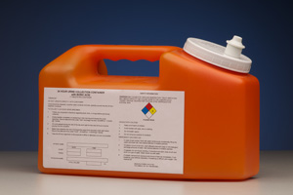
Please read through all instructions entirely before starting collection. If you have any questions about collection please contact your laboratory.
Beginning Process:
- Select a time to start, example 7:00 a.m., write your name, birthday, height and weight on container label.
- Completely empty your bladder into the toilet.
- Write the time and date on the container label as the Start time and Start Date.
The next time you use the bathroom and EVERY time you urinate for the next 24 hours:
- Completely empty your bladder into the clean, dry plastic container provided.
- Pour ALL the urine into the jug each time.
- Close the lid of jug tightly after each time you add to the jug, and swirl jug to mix.
- Keep jug at a refrigerated temperature during the entire collection time. This can be either in your refrigerator or in a cooler with ice inside next to your toilet.
At the end of collection:
- Collect the last urine specimen exactly 24 hours after the first specimen.
- Write the time and date on the container label as Finish time and Finish Date.
- Return to facility as soon as possible after collection to ensure proper handling and processing of your specimen.

Iron County Medical Center Laboratory 301 N Hwy 21, Pilot Knob, MO 63663

