Patient Instructions: C. Diff
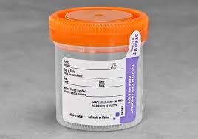
Sterile Container
Please read through all instructions entirely before starting collection. If you have any questions about collection please contact your laboratory.
- First pass urine in toilet. Collect stool in empty plastic container or place a plastic wrap over toilet and pass stool on the plastic. DO NOT LET URINE OR WATER TOUCH THE STOOL SPECIMEN. If patient is in diapers, line the diaper with plastic wrap so stool does not soak in fibers.
- Unscrew the cap, and using a wooden paddle or plastic spoon, collect stool into the container. Fill container no more than halfway.
- Replace the cap on the container, making sure cap is tight.
- Wash hands with soap and water.
- Fill out the label on the container, including your name, date of birth, date and time of collection.
- Return to facility as soon as possible in one of the following ways to ensure stability of sample: 2 hours room temperature or 24 hours refrigerated temperature.

Iron County Medical Center Laboratory 301 N Hwy 21, Pilot Knob, MO 63663, phone 573-546-8021

